**Scenario -1**

**Creating EC2 instance in AWS using Ansible which is available in local on-premise server**

Boto , python and ansible installation on Linux

Installing Ansible,python,boto on ubuntu 20.4

**Update Repository by including the official project’s PPA**

sudo apt-get update

sudo apt-add-repository -y ppa:ansible/ansible

**Refresh the package**

sudo apt-get update

**install ansible**

sudo dpkg –configure -a

sudo apt-get install -y ansible

**Installing package manager for Python on ubuntu 20.4**

sudo apt install python3-pip -y

**Installing Boto framework -AWS SDK**

Ansible will access AWS resources using boto SDK

sudo apt-get install python3-boto -y

sudo pip install boto boto3 [Some data center support boto and some boto 3]

**Check ansible/boto installation**

ansible –version

pip list boto | grep boto

pip show boto3Fall-

AWS account with privilege to Launch EC-2 Instance

<https://www.middlewareinventory.com/blog/ansible-aws-ec2/>

**Installation On Mac**

**Installing Python Package Manager**

Python Package Manager (PyPM) is a Python utility intended to simplify the tasks of locating, installing, upgrading and removing Python packages

* Check your Python version to make sure Python3 is installed

python3 –version

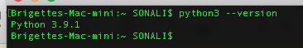

* Down load pip by running the following command

curl <https://bootstrap.pypa.io/get-pip.py> -o get-pip.py



* Installed the download package by running the following command

python3 get-pip.py



* Verify the successful installation pf PIP package

pip –version



**Installing Ansible**

* Use pip to install Ansible

sudo pip install ansible

* Down load pip by running the following command

ansible --version

**Installing Boto, Boto3**

**What is Boto?**

Boto is an Amazon AWS SDK for [python](https://crunchify.com/ansible-how-to-grep-ps-few-and-kill-process-running-on-remote-host/). Ansible internally uses Boto to connect to Amazon EC2 instances and hence you need Boto library in order to run [Ansible](https://crunchify.com/what-is-ansible-pre_tasks-how-to-update-os-install-python-and-install-jre-on-remote-host/) on your laptop/desktop.

Some data center support boto and some boto 3

* Use the following command to install boto3

pip install boto3 --user

* Use the following command to install boto

pip install boto --user

* Check the version installed both for boto and boto3

pip list boto | grep boto

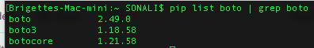

**Installing AWS CLI**

The AWS Command Line Interface (AWS CLI) is an open source tool that enables you to interact with AWS services using commands in your command-line shell.

* For the latest version of the ASW CLI, use the following command block

curl "https://awscli.amazonaws.com/AWSCLIV2.pkg" -o "AWSCLIV2.pkg"

sudo installer -pkg AWSCLIV2.pkg -target /

* To check whether aws cli installed correctly

aws –version



For details of install/uninstall/update please follow the following link from AWS

<https://docs.aws.amazon.com/cli/latest/userguide/install-cliv2-mac.html#cliv2-mac-install-gui>

**How connect to AWS EC2 Instance by using command line argument from AWS CLI on Linux/Mac?**

* Go to: https://console.aws.amazon.com/iam/home?#/users
* Create user

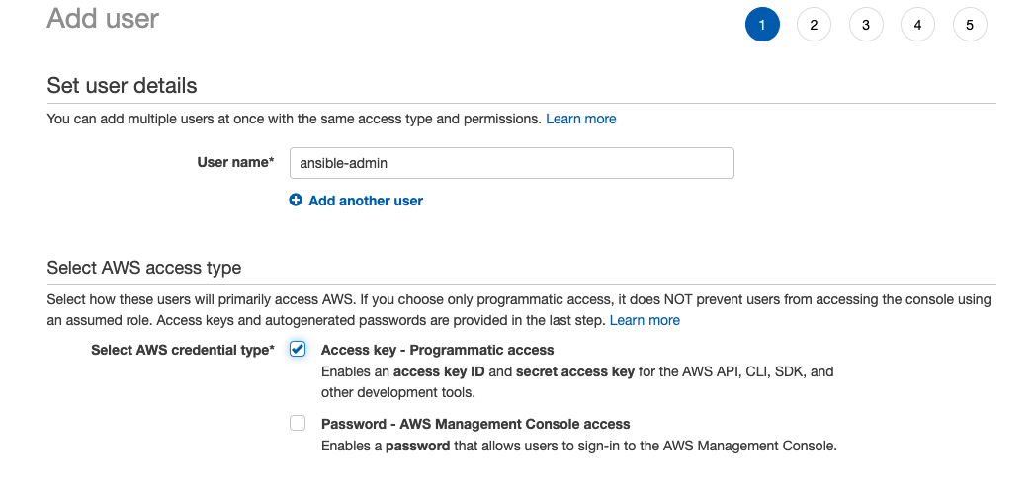

* Set permission by clicking on Attach existing policies directly

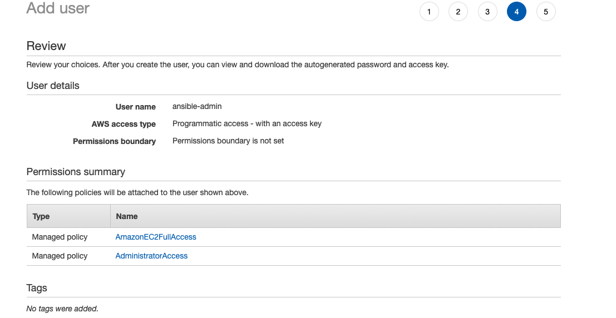

* Download Amazon AWS Access Key ID, Secret Access Key

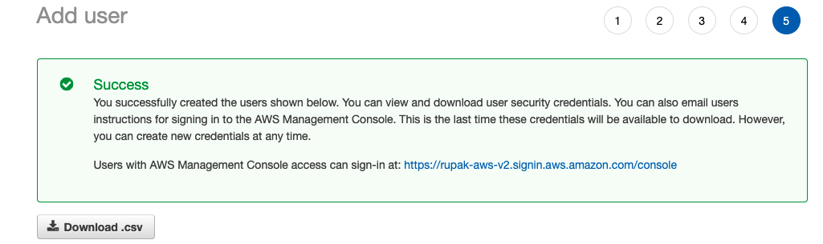

* Make sure One of the EC2 instance is up and running if not create a new EC2 instance



* Set up Amazon AWS credential

There are many ways we can set up Amazon AWS credential

Just type aws configure command. Enter your Amazon Access key ID and Secret access key.

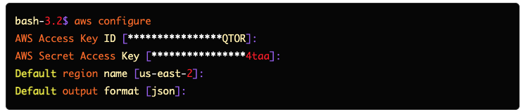

* Run the following command from your command line of mac/linux to get the ec2 instance details

aws ec2 describe-instance

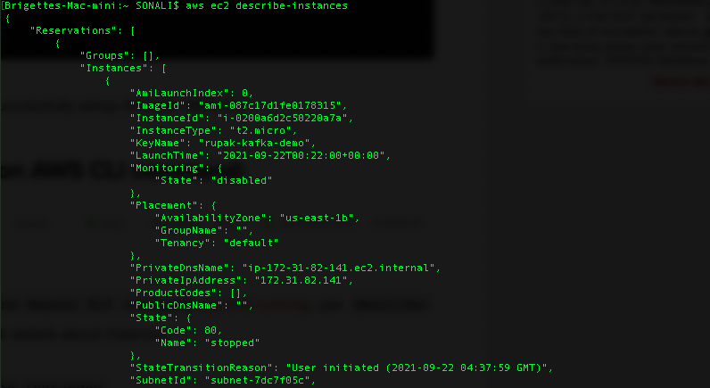

**AWS – Create a new EC2 Using Ansible Playbook**

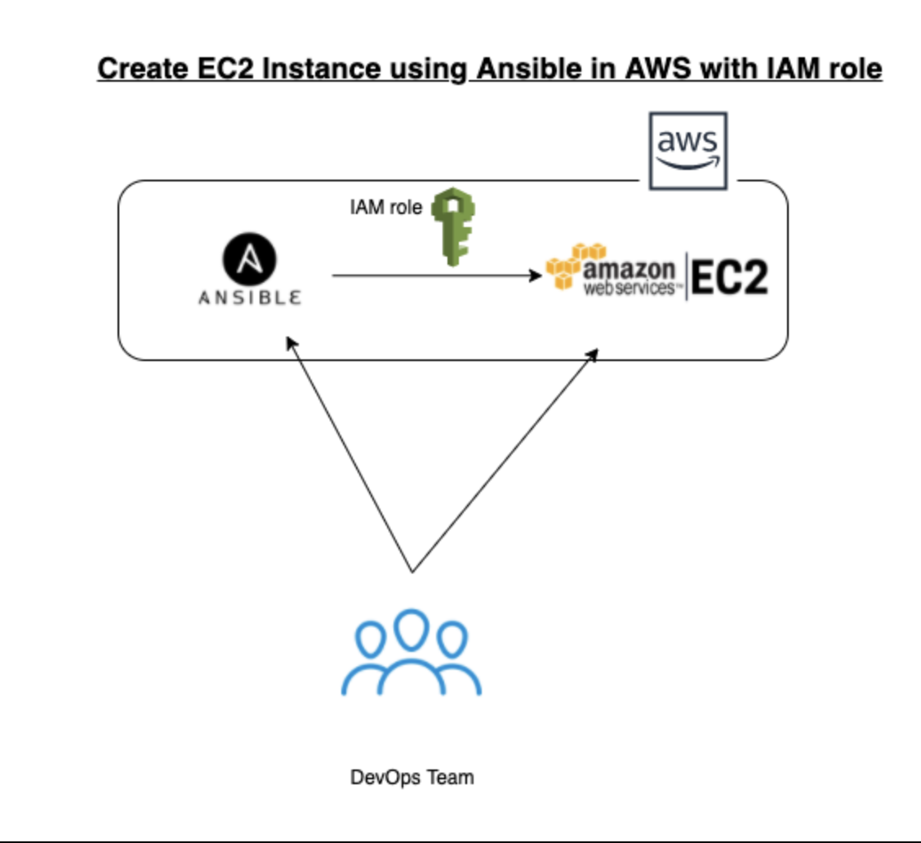

**Step-1 : Create Access Key**

We must create an access key for our ansible on the controller node to be able to access the AWS account. Click on the **username** on your AWS Portal and from the drop down menu select "**My Security Credentials**"

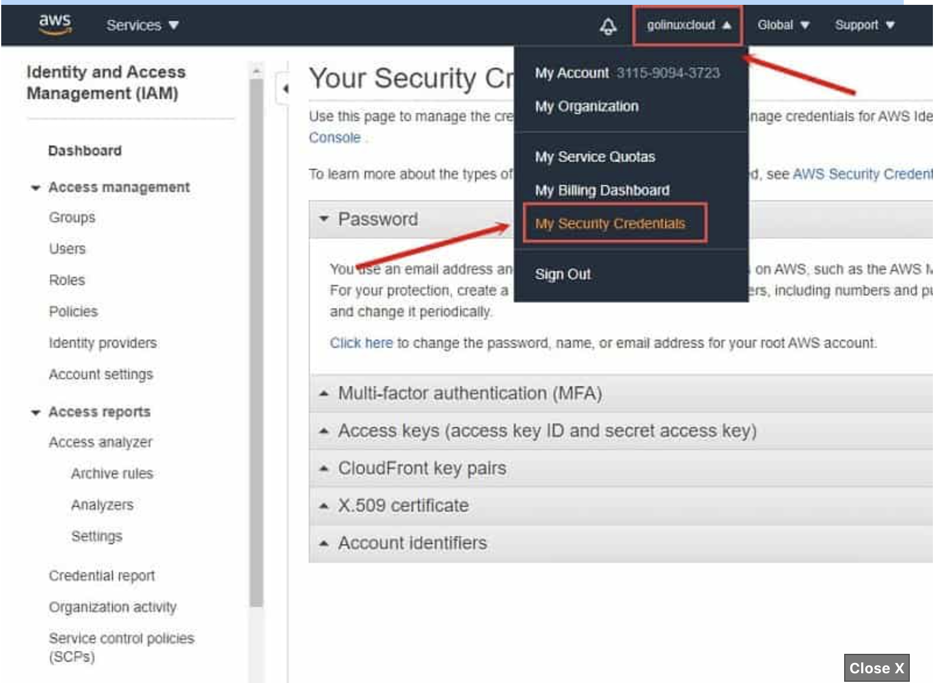

Next click on "**Access keys (access key ID and secret access key)**" to expand the drop down menu and click on "**Create New Access Key**"

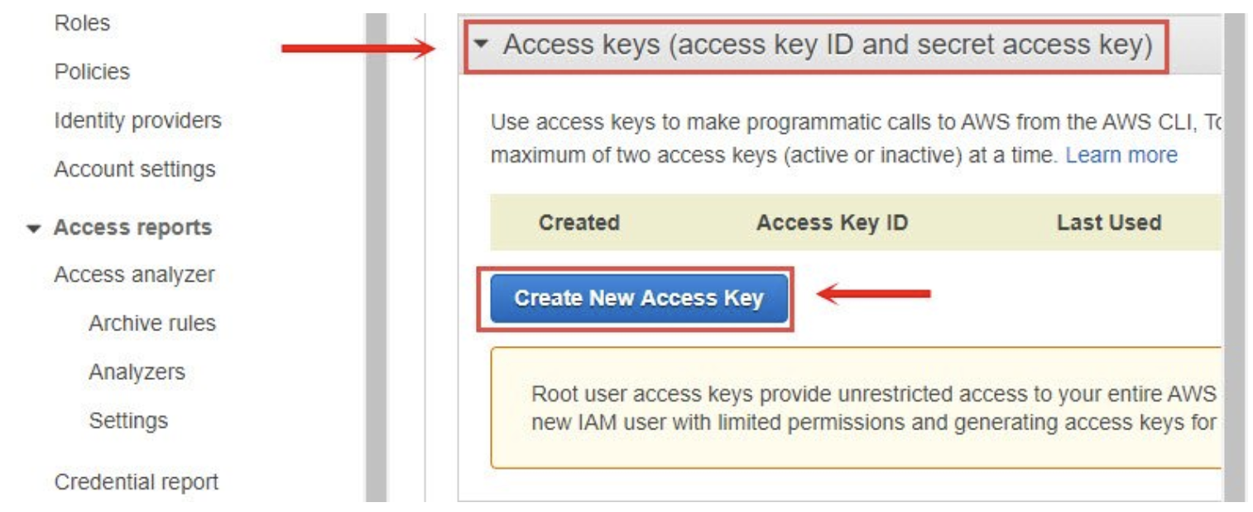

This should create a new access key. It is **IMPORTANT** that you either download the key file or save both Access Key ID and Secret Access Key as you will not be able to retrieve this later as the message says on the console.

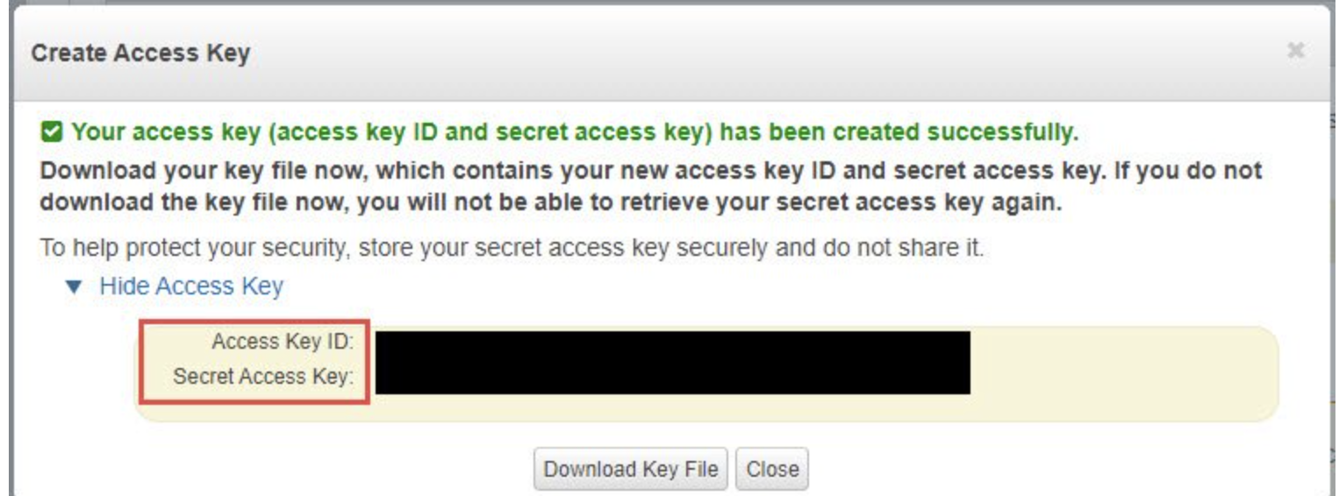

**Step-2 : Store Access Key**

We will use awscli to store our login credentials instead of the playbook for better security which requires awscli tool. We can install awscli using pip3 as instructed above. Make sure aws cli is installed .

Now we can store our access key using awscli. Execute **aws configure** from the console as ansible user:

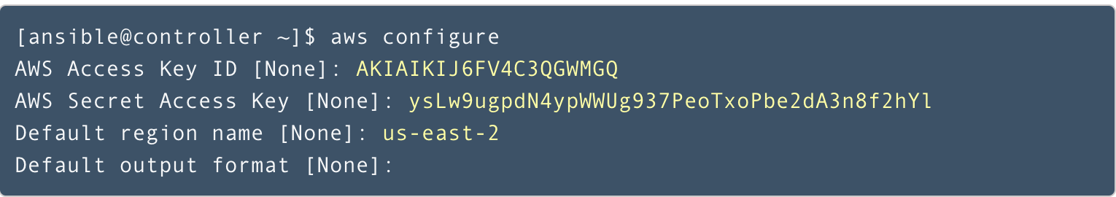

Now you can access your configuration which will be stored in the home folder of ansible user under ~/.aws

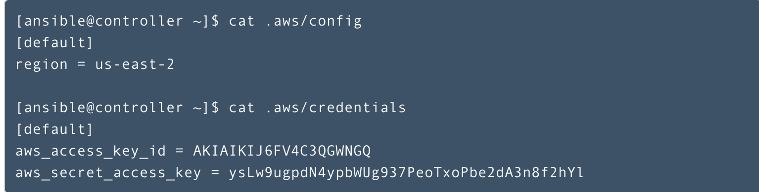

**Step-3 : Create or Edit Ansible host(inventory) file**

The Ansible inventory file defines the hosts and groups of hosts upon which commands , modules and tasks in a playbook operate. By default when you install ansible it can be found (ubuntu Linux) at the path /etc/ansible/hosts .

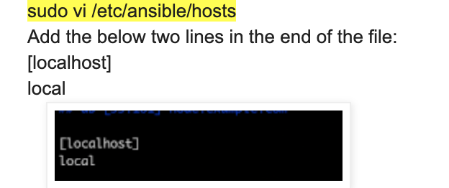

you can open the file and edit it or you can create a inventrory file in any directory you like to create and and the following entry

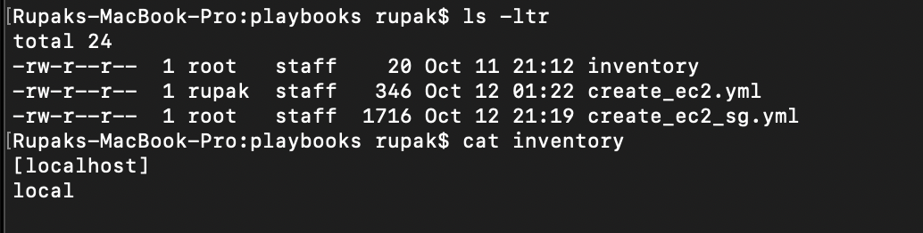

**Step-4 : Create Ansible playbook file to provision a new EC2 instance**

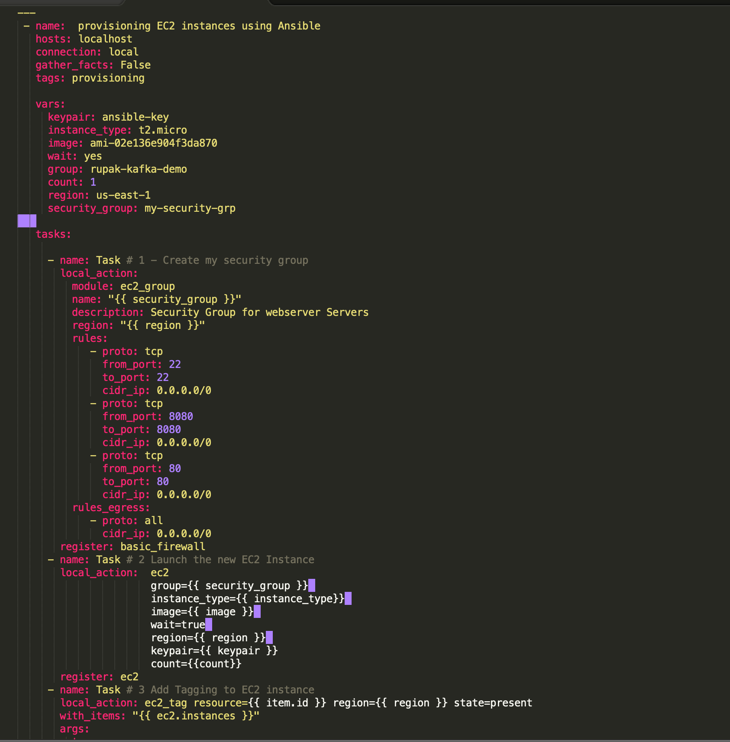



**Step-4 : Execute Ansible playbook command**

Ansible Playbook

sudo ansible-playbook -i inventory create_ec2_sg.yml --key-file "~/.ssh/id_rsa.pub" --connection=local -e "ansible_python_interpreter=/usr/local/bin/python3"

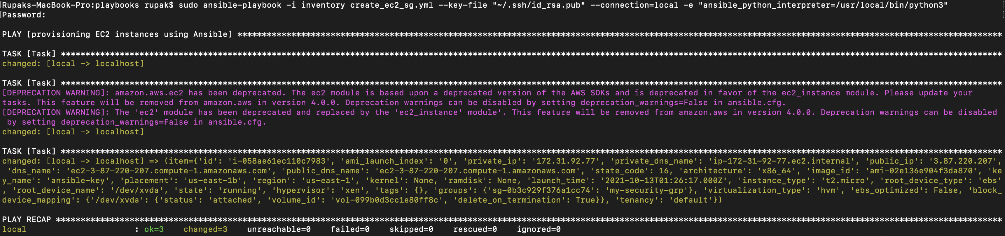

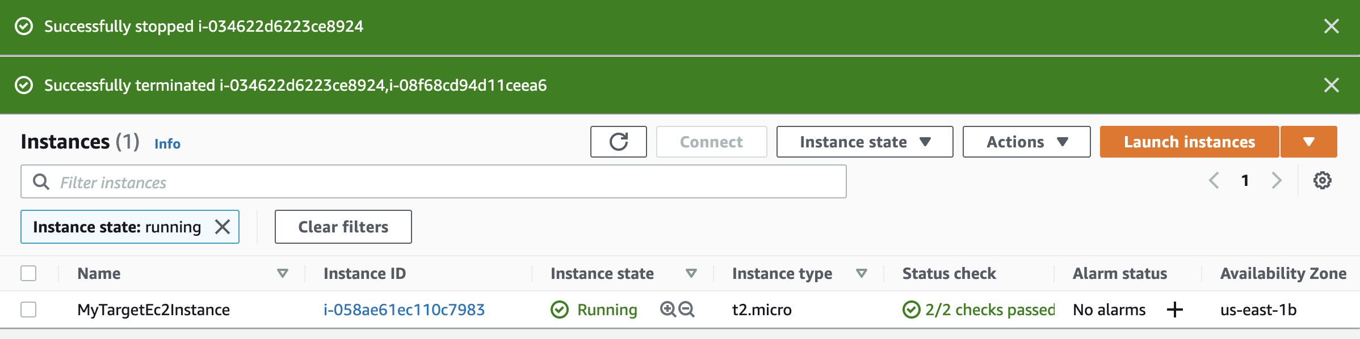

**AWS – Start a stopped EC2 Using Ansible Playbook**

**Step-1 : Create Ansible playbook file to Strat EC2 instance**

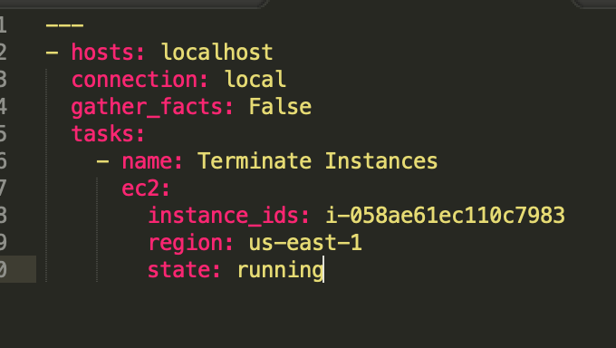

**Step-1 : Run the following ansible play command**

sudo ansible-playbook -i inventory ec2_start.yml --key-file "~/.ssh/id_rsa.pub" connection=local -e "ansible_python_interpreter=/usr/local/bin/python3"

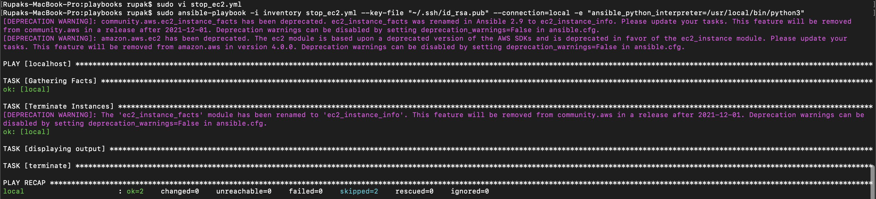

**AWS – Stop a already Started EC2 instance Using Ansible Playbook**

**Step-1 : Create Ansible playbook file to Stop EC2 instance**

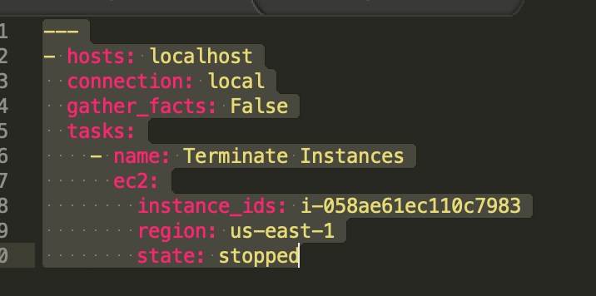

**Step-2 : Run the following ansible play command**

sudo ansible-playbook -i inventory ec2_stop.yml --key-file "~/.ssh/id_rsa.pub" --connection=local -e "ansible_python_interpreter=/usr/local/bin/python3"

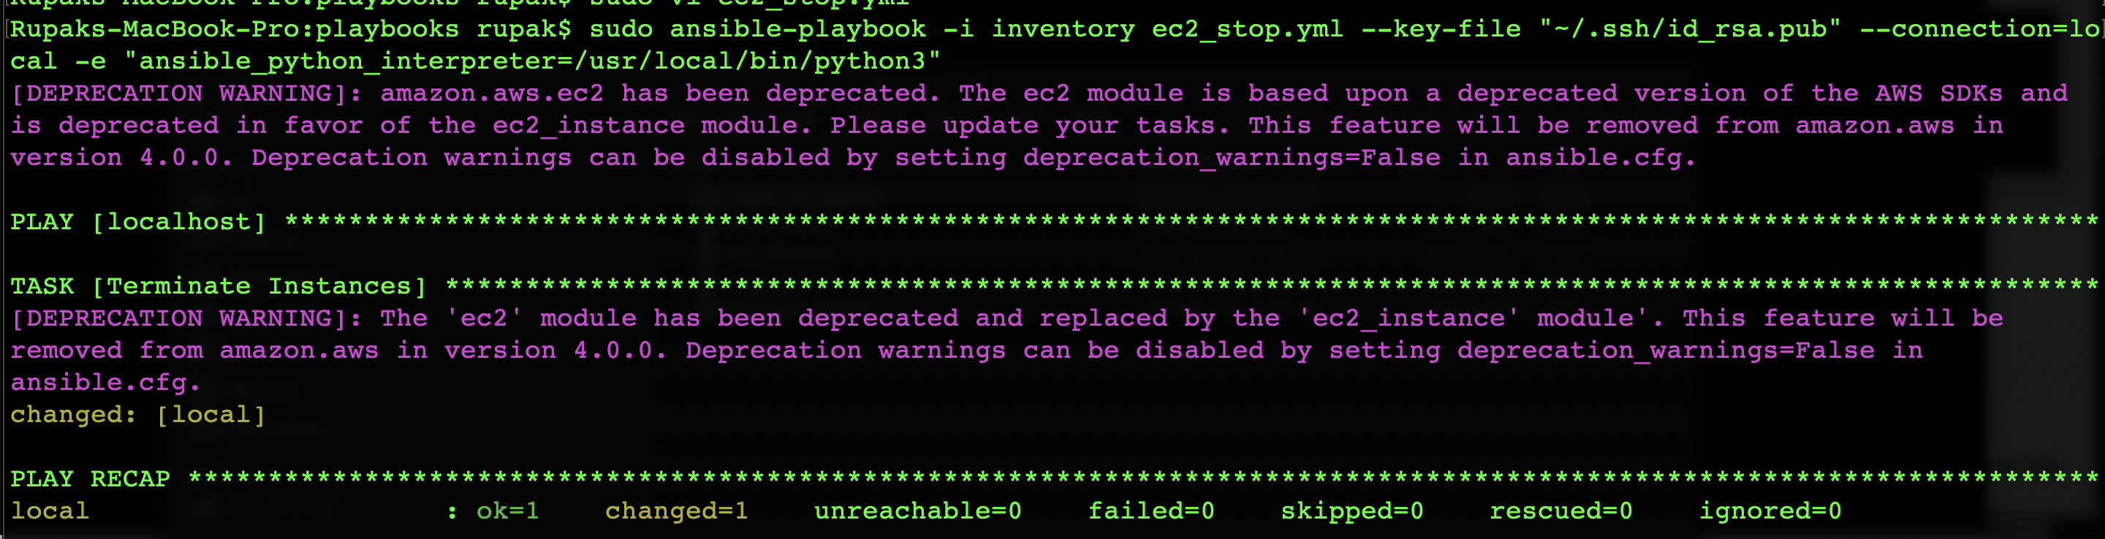

**AWS – Terminate EC2 instance Using Ansible Playbook**

**Step-1 : Create Ansible playbook file to Stop EC2 instance**

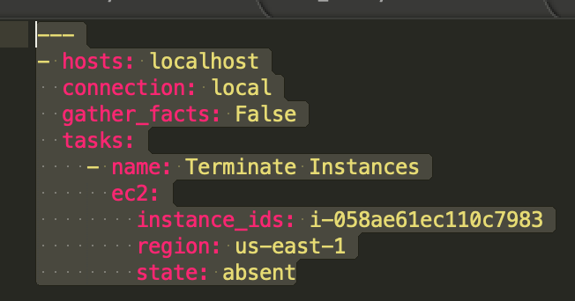

**Step-2 : Run the following ansible play command**

sudo ansible-playbook -i inventory ec2_terminate.yml --key-file "~/.ssh/id_rsa.pub" --connection=local -e "ansible_python_interpreter=/usr/local/bin/python3"

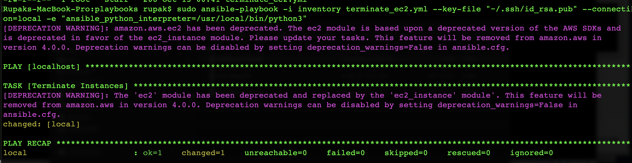

**AWS – Deploying Kafka, Zookeeper from Ansible Master Node To Remote Slave**

* Create one Ansible Controller (Master ) .
* Create two EC2 instances where the master ansible playbook will automatically install kafka broker , Zookeeper and also manage there state
* Install Ansible in Ansible Controller node
* Create SSH keys for Ansible Controller node and copy the keys to remote hosts for password less Authentication
* Create roles using ansible galaxy and deploy it on Ansible Controller

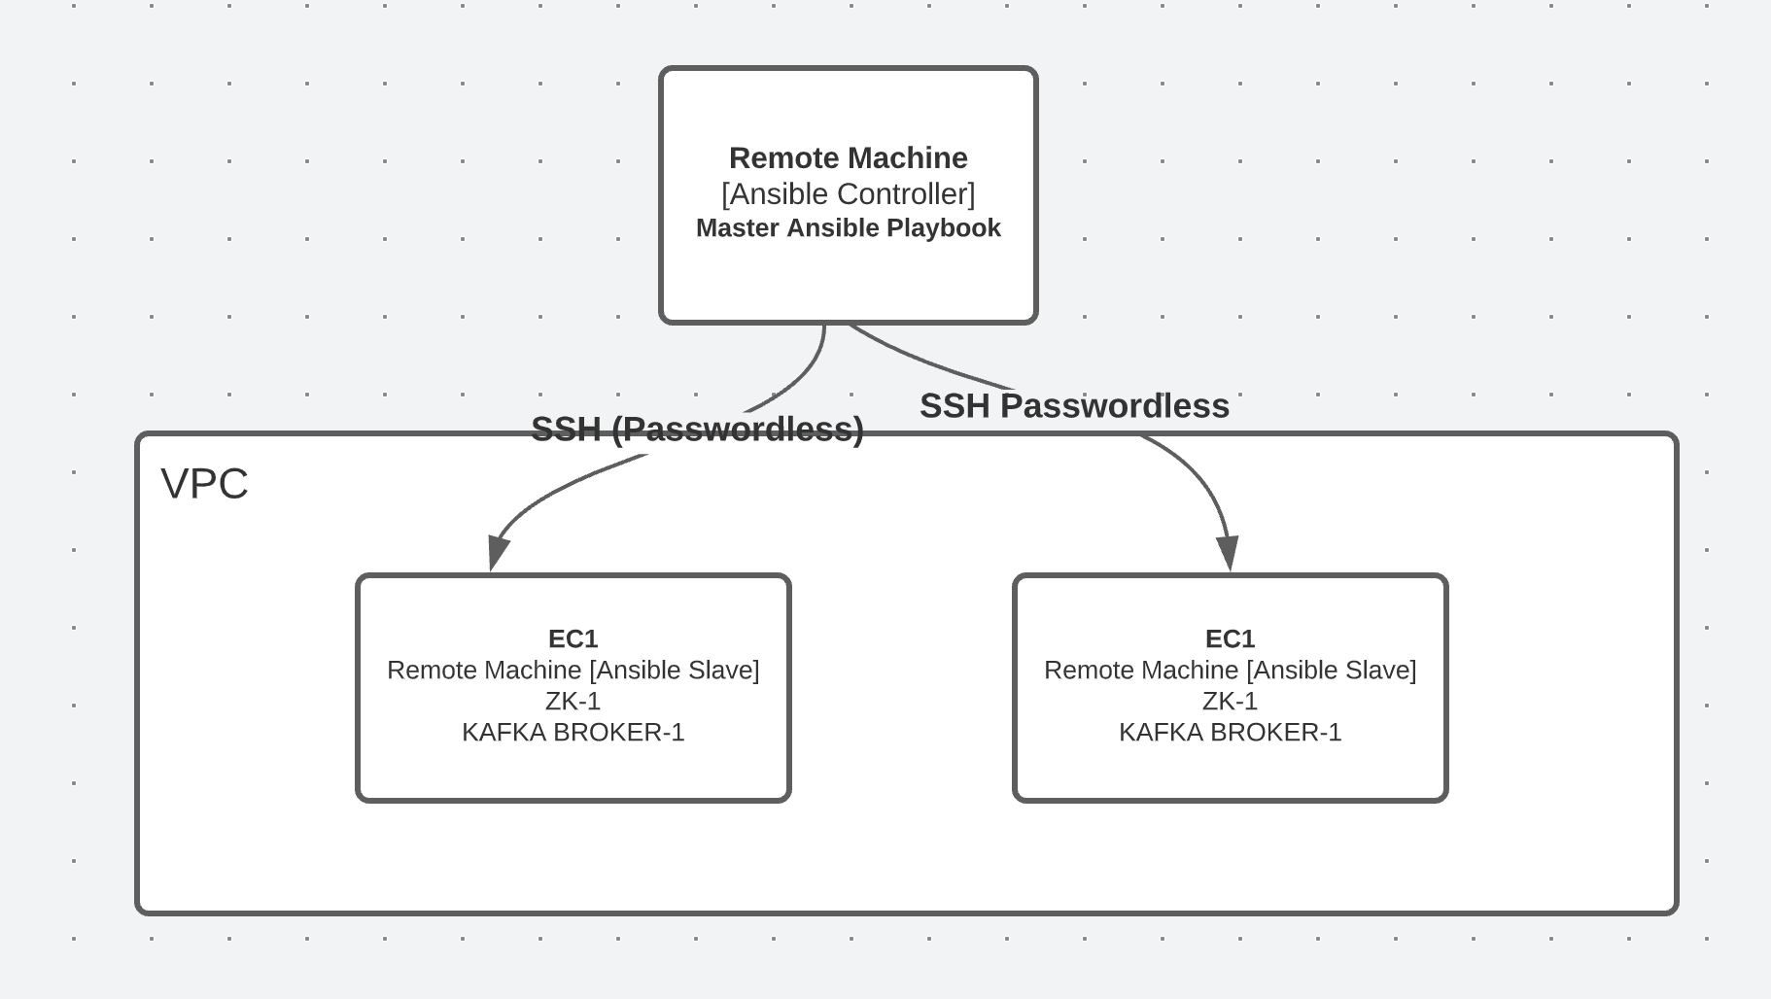

**Step-1 [Create EC2 instances ]**

Create 3 EC2 instances . Here I am creating instances for Red Hat Enterprise Linux 8 (HVM), SSD Volume Type .

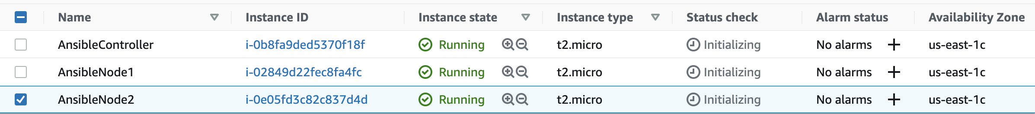

**Step-2 [Connect to AnsibleController EC2 instance to Add User and Set PassWord ]**

* Open a terminal and used the command mentioned in the EC2 Connect tab to connect to remote EC2 ansible controller

sh -i "ansible-master-slave.pem" ec2-user@ec2-34-203-31-176.compute-1.amazonaws.com

* sudo su –
* add user by using the following command

useradd ansibleuser

* set the pass word of the user by executing the following command [15 letter recommended]

passwd ansibleuser

* visudo
* add the ansibleuser [to login without password]

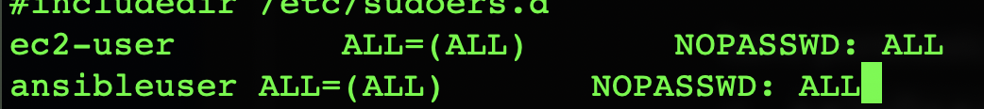

* To enable password less authentication make the following changes in sshd_config. We can login to this box from remote machine without any password

vi /etc/ssh/sshd_config

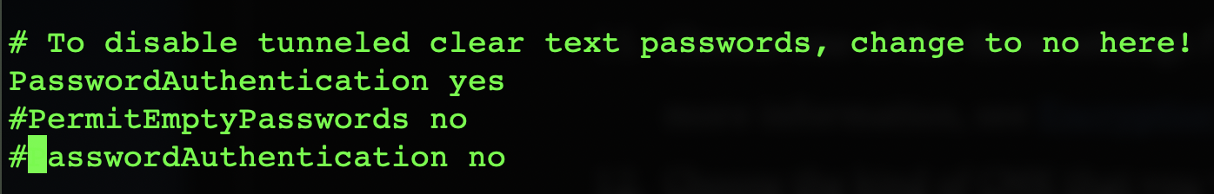

* Restart the sshd by applying the following command

systemctl restart sshd

* Add the other two instances[slaves] private ip address inside the hosts file of Ansible controller instance

vi /etc/hosts

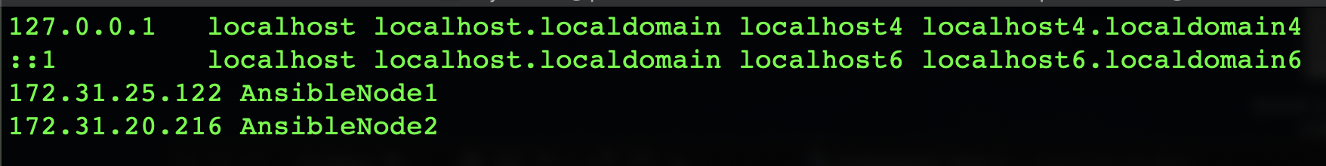

**Step-3 [Connect to Ansible Slave EC2 instances to make it elgible for password less authentication]**

* Connect the Ansible slave instances and follow the steps as exactly mentioned in Step-2

**Step-4 [Conenct to Ansible Controller via SSH ]**

Try to connect to ansible controller node form remote machine using the SSH command as shown below. It will going to ask for the password as we yet to create the SSH key and copied .

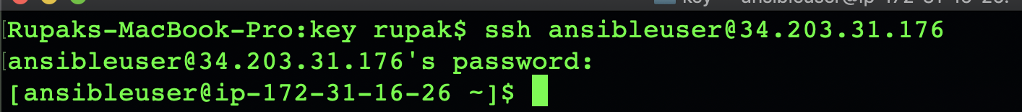

**Step-5 [Create SSH Key and copy it to Slave nodes for passwordless Authentication ]**

* Connect the AnsibleController Node
* Use the following command to generate the private and public key

**ssh-keygen**

* Do not use any filepath or password .Once created check the whether the keys are created using the following command

**cd .ssh**

**ls -ltr**

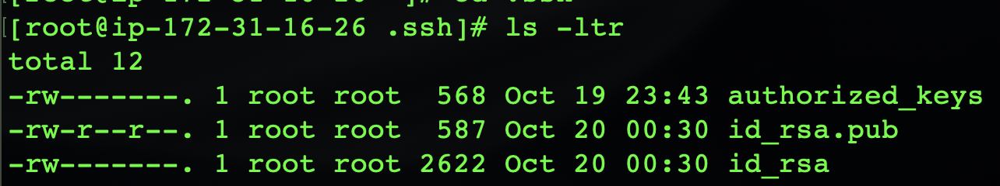

**Step-5 [Create SSH Key and copy it to Slave nodes for passwordless Authentication ]**

ssh-copy-id ansibleuser@AnsibleNode1

ssh-copy-id ansibleuser@AnsibleNode2

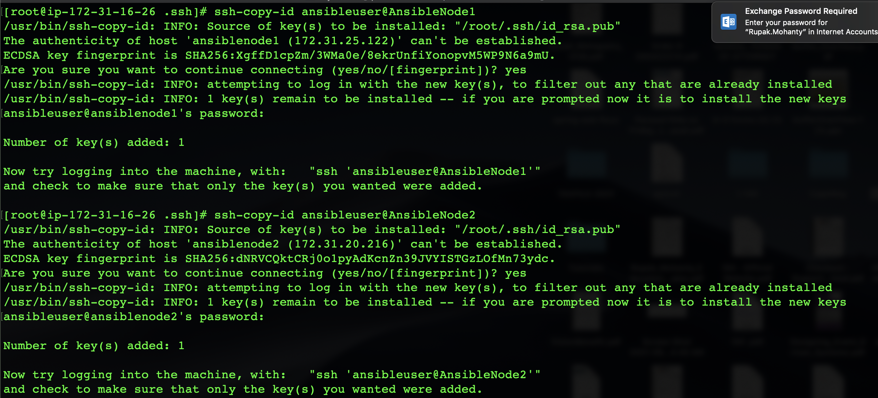

**Step-6 [ Check passwordless Authentication]**

* Check whether you are able to connect to the slave nodes from master node without using passwords

ssh ansibleuser@AnsibleNode1

ssh ansibleuser@AnsibleNode2

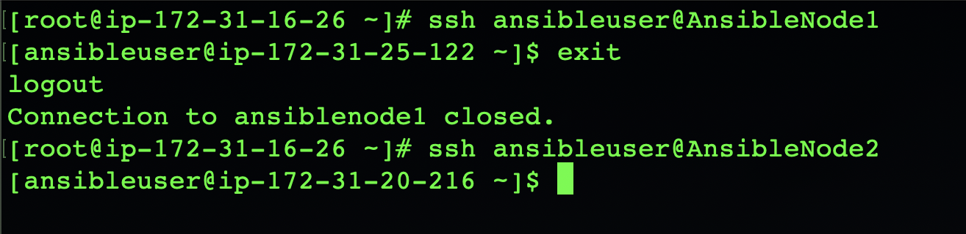

**Step-7 [Install Ansible on AnsibleController Node]**

yum install <https://dl.fedoraproject.org/pub/epel/epel-release-latest-8.noarch.rpm>

yum install ansible -y

Check Ansible version after installation

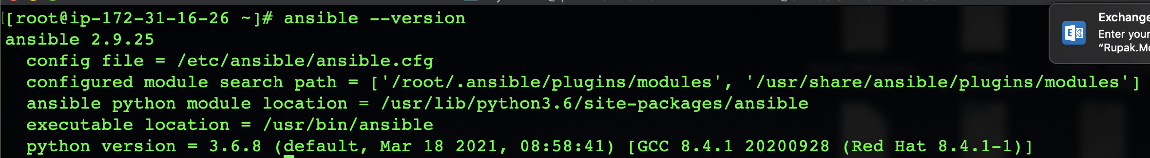

**Step-8 [Create a inventory in Ansible Master node to add the Slave Nodes]**

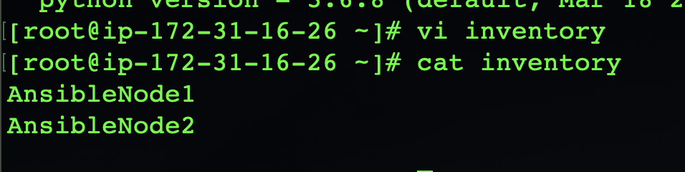

**Step-8 [Create a project in Ansible Controller or Master Node and copy the inventory file inside the project ]**

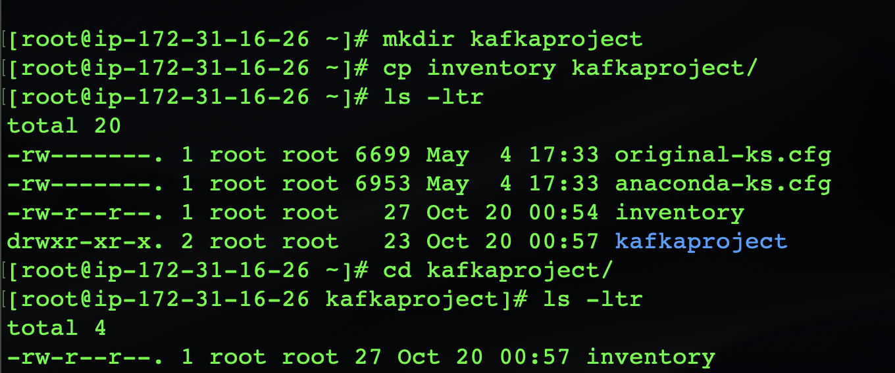

**Step-8 [Add the slave nodes to Ansible Controller Node so that Ansible Controller know which all node it can connect ]**

Update the hosts file to add the salve nodes public IP address

vi /etc/ansible/hosts

add the following entries for slave nodes . The name can be naything other then production

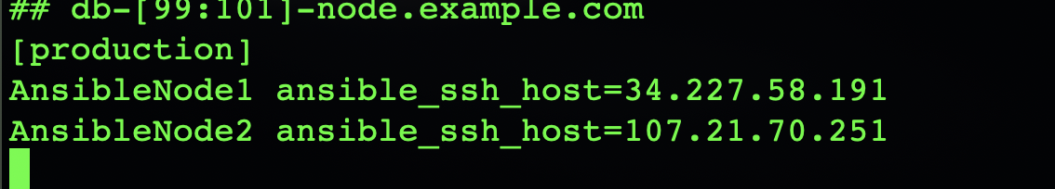

**Step-9 [Test from AnsibleController node whether you can ping to salve nodes ]**

Use the below command

ansible all -m ping

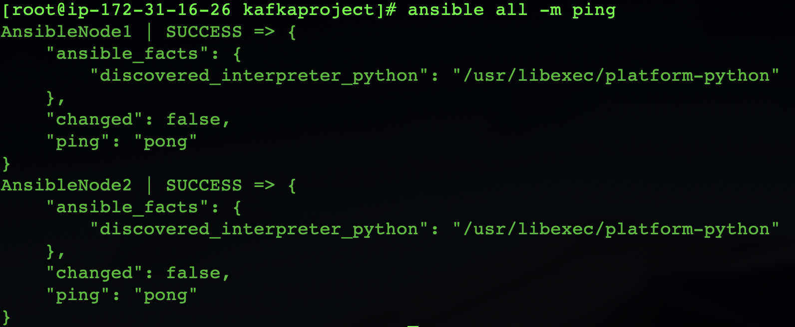

**Step-10 [Create the ansible.cfg file with following content ]**

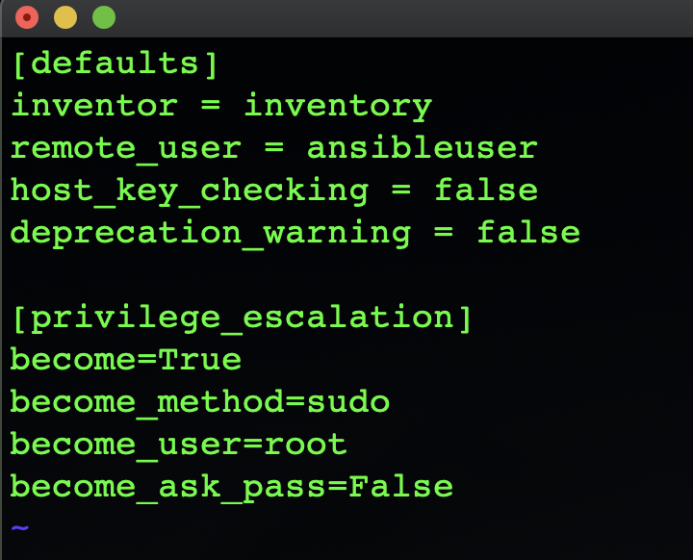

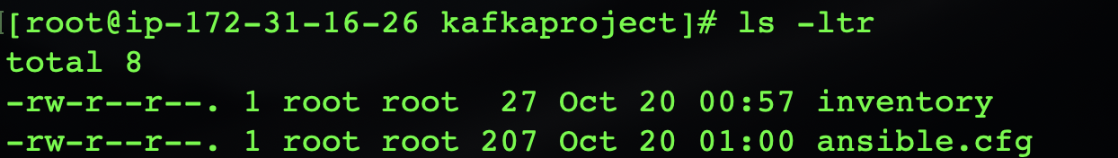

**Step-11 [install ansible galaxy for Kafka roles on AnsibleController ]**

Go to <https://galaxy.ansible.com/search?deprecated=false&keywords=kafka&order_by=-relevance&page=1> Search for kafka

Select the one as shown below

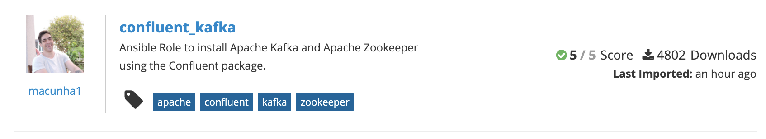

Run the following command

ansible-galaxy install macunha1.confluent_kafka

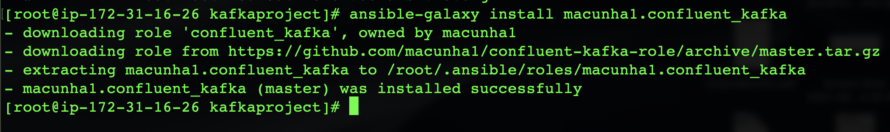

Copy the installation to current project folder i.e kafkaproject folder

cp -r /root/.ansible/roles/macunha1.confluent_kafka/ .

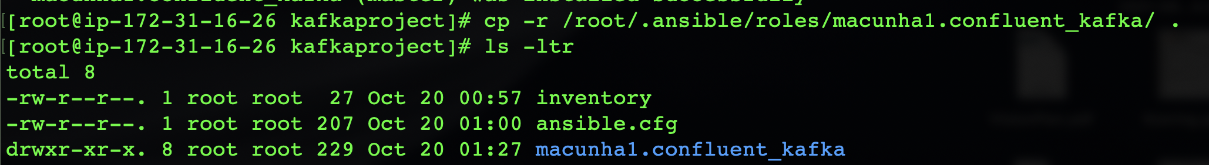

Run the requirements.yaml file under the macunhal.confluent_kafka folder to install the mandatory java

ansible-galaxy install -r requirements.yaml

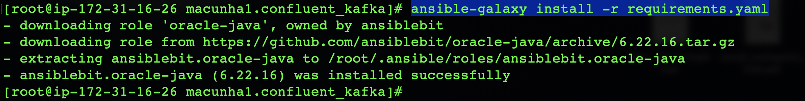

Copy the installation to current project folder i.e kafkaproject folder

cp -r /root/.ansible/roles/ansiblebit.oracle-java/ .

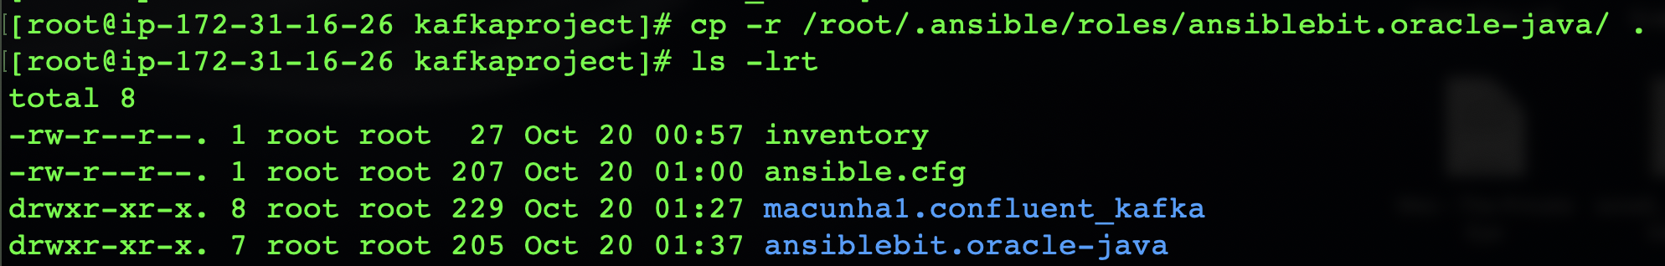

All details are there inside readme file which can be read

Update the inventory file to add the details where we need to install kafka and zookeeper [Refer to Example inventory in read me file]

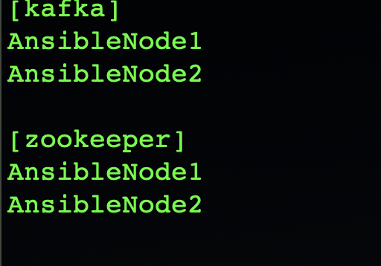

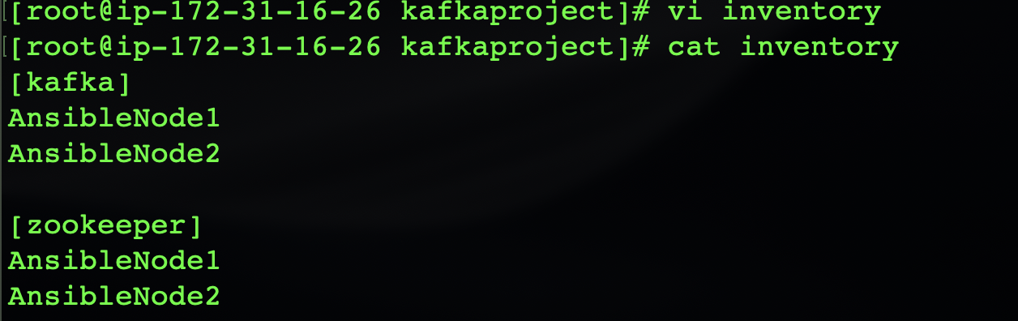

Create a kafka.yaml [Playbook for Ansible Controller]

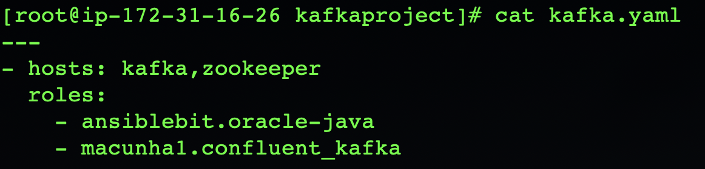

**Step-12 [Run playbook from AnsibleController to install Zookeepr and Kafka on Slave Node]**

Run the following command

ansible-playbook -i inventory -vv kafka.yaml

following error occurred which means it is failed to download the required java

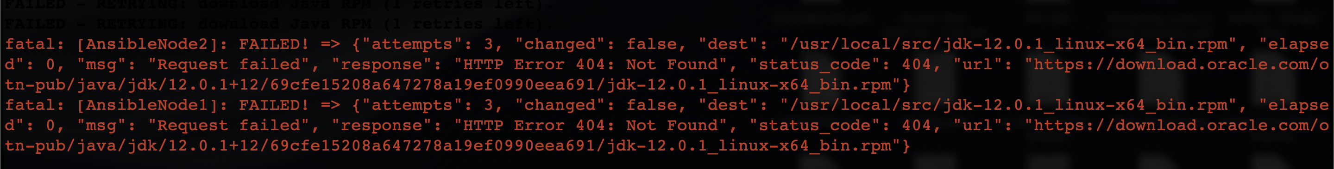

Try to install an alternative java version. Run the below command

ansible-galaxy install geerlingguy.java

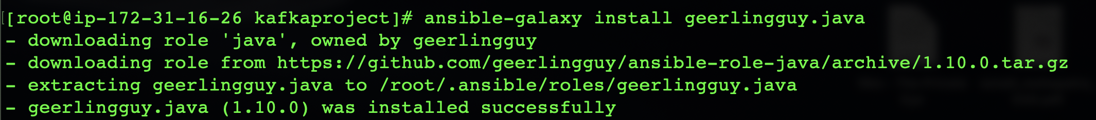

Copy the java installation within the kafkaprojects

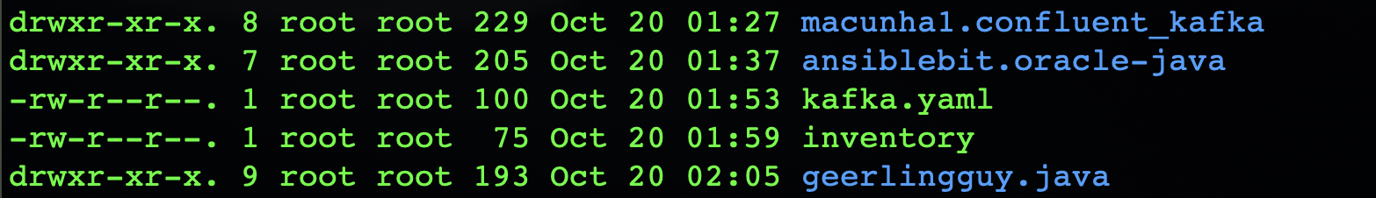

Change the role in kafka.yaml file to geerlingguy.java

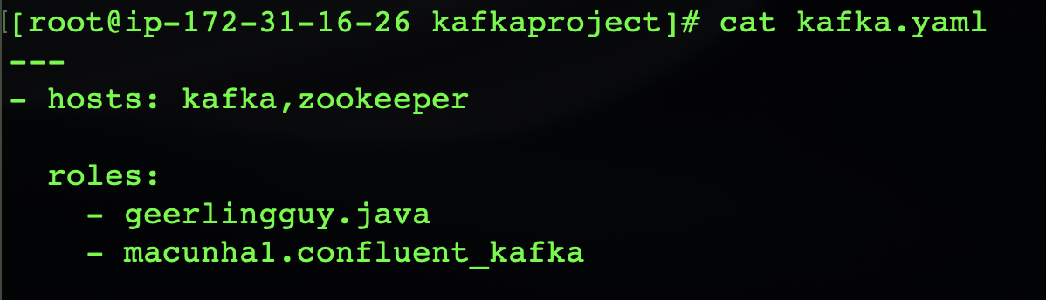

Run the playbook command again

ansible-playbook -i inventory -vv kafka.yaml

**Step-12 [SSH to any of the slave node and validate the kafka and zookeeper installation]**

find / -name kafka

find /-name zookeeper

nc -vz localhost 2181

nc -vz localhost 9092

**Assignment -2**

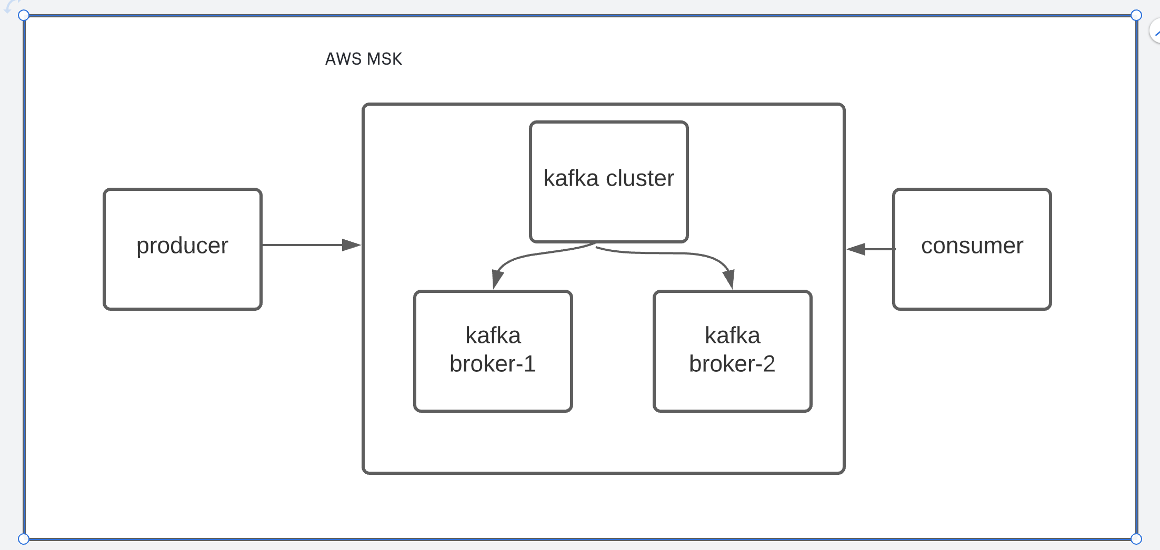



**Description :**

Publishing message from client instances deployed in an EC2 instance in AWS to a Kafka cluster ( AWS MSK Cluster) and consuming message from another client instance deployed within same or different EC2 instance.

**What is Amazon MSK :**

Amazon MSK is a new AWS streaming data service that manage kafka infrastructure and operation.Basically it is an managed kafka cluster

**Steps for the demo :**

1. Create Kafka Cluster using AWS MSK.

<https://docs.aws.amazon.com/msk/latest/developerguide/msk-create-cluster.html>

1. Open the Amazon MSK console at <https://console.aws.amazon.com/msk/>.
2. Choose **Create cluster**.
3. Specify a name for the cluster.
4. In the VPC list, choose the VPC you want to use for the cluster. You can also specify which version of Apache Kafka you want Amazon MSK to use to create the cluster.
5. Specify two subnets if you're using one of the following Regions: South America (São Paulo), Canada (Central), and US West (N. California). In other Regions where Amazon MSK is available, you can specify either two or three subnets. The subnets that you specify must be in different Availability Zones.
6. Choose the kind of configuration you want. For information about MSK configurations, see [Amazon MSK Configuration](https://docs.aws.amazon.com/msk/latest/developerguide/msk-configuration.html).
7. Specify the type and number of brokers you want MSK to create in each Availability Zone. The minimum is one broker per Availability Zone and the maximum is 30 brokers per cluster.
8. (Optional) Assign tags to your cluster. Tags are optional. For more information, see [Tagging an Amazon MSK Cluster](https://docs.aws.amazon.com/msk/latest/developerguide/msk-tagging.html).
9. You can adjust the storage volume per broker. After you create the cluster, you can increase the storage volume per broker but you can't decrease it.
10. Choose the settings you want for encrypting data in transit. By default, MSK encrypts data as it transits between brokers within a cluster. If you don't want to encrypt data as it transits between brokers, clear the check box labeled **Enable encryption within the cluster**.
11. Choose one of the three settings for encrypting data as it transits between clients and brokers. For more information, see [Encryption in Transit](https://docs.aws.amazon.com/msk/latest/developerguide/msk-encryption.html#msk-encryption-in-transit).
12. Choose the kind of CMK that you want to use for encrypting data at rest. For more information, see [Encryption at Rest](https://docs.aws.amazon.com/msk/latest/developerguide/msk-encryption.html#msk-encryption-at-rest).
13. If you want to authenticate the identity of clients, choose **Enable TLS client authentication** by selecting the box next to it. For more information about authentication, see [Mutual TLS Authentication](https://docs.aws.amazon.com/msk/latest/developerguide/msk-authentication.html).
14. Choose the monitoring level you want. This determines the set of metrics you get. For more information, see [Monitoring an Amazon MSK Cluster](https://docs.aws.amazon.com/msk/latest/developerguide/monitoring.html).
15. (Optional) Choose **Advanced settings**, and then choose **Customize settings**. You can specify one or more security groups that you want to give access to your cluster (for example, the security groups of client machines). If you specify security groups that were shared with you, you must ensure that you have permissions to them. Specifically, you need the ec2:DescribeSecurityGroups permission. For an example, see [Amazon EC2: Allows Managing EC2 Security Groups Associated With a Specific VPC, Programmatically and in the Console](https://docs.aws.amazon.com/IAM/latest/UserGuide/reference_policies_examples_ec2_securitygroups-vpc.html).
16. Choose **Create cluster**.

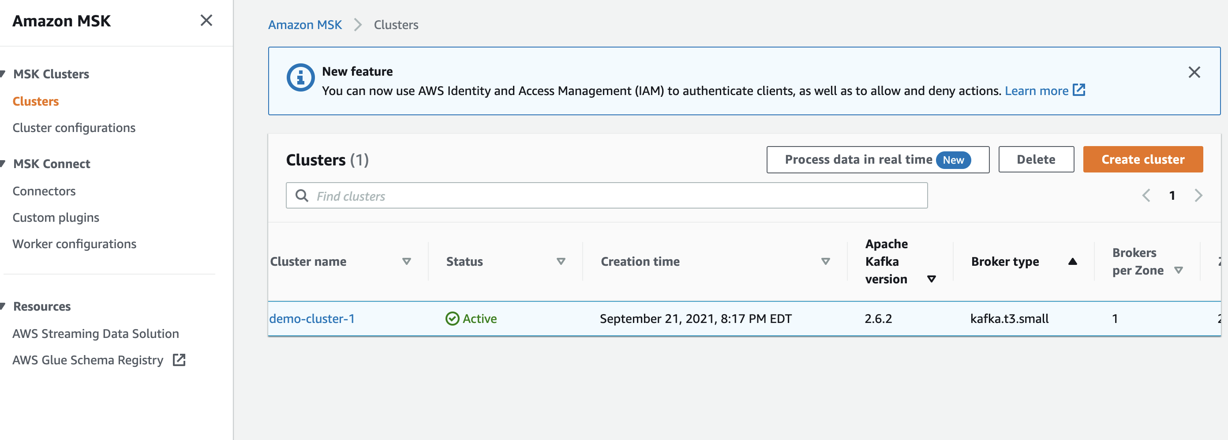

1. Install AWS CLI

<https://docs.aws.amazon.com/cli/latest/userguide/cli-chap-install.html>

1. Create a EC2 instance to host the producer and consumer.
2. Install java and Kafka on EC2 instance ( Considering Amazon Linux EC2 instance)

* Open a terminal and SSH to EC2 instance
* install Java: sudo yum install java-1.8.0
* Get Kafka:wget <https://archive.apache.org/dist/kafka/2.2.1/kafka_2.12-2.2.1.tgz>
* Extract Kafka: tar -xzf kafka_2.12-2.2.1.tgz

1. Get the zoo keeper connection string and other information about your cluster by entering the following code

* Open a terminal
* Make sure AWS CLI is already installed
* Execute the below command
* aws kafka describe-cluster --region <region-name> --cluster-arn <MSK Cluster arn>
* Example is given below
* aws kafka describe-cluster --region us-east-1 --cluster-arn arn:aws:kafka:us-east-1:246653441795:cluster/demo-cluster-1/ee4ad7f;2C1-3b88-4e00-8ae4-460e6082b8ca-19.
* Copy the zookeeper string which will be used to create the topic

1. Create a kafka topic

* Open up a terminal
* SSH to EC2 instance
* cd kafka_2.12-2.2.1/
* bin/kafka-topics.sh --create --zookeeper "ZookeeperConnectString" --replication-factor 2 --partitions 1 --topic <topicname>
* replace the ZookeeperConnectString with the value generated in step-5
* example command is given below
* bin/kafka-topics.sh --create --zookeeper "z-1.demo-cluster-1.usw9js.c19.kafka.us-east-1.amazonaws.com:2181,z-2.demo-cluster-1.usw9js.c19.kafka.us-east-1.amazonaws.com:2181,z-3.demo-cluster-1.usw9js.c19.kafka.us-east-1.amazonaws.com:2181" --replication-factor 2 --partitions 1 --topic AWSKafkaTutorialTopic

1. Generate the client and server certificate by copying the certificate from JRE’s certificate

Form the same terminal connecting to EC2 instance use the following command

* cd /home/ec2-user
* cd /
* ls
* cd /usr
* cd /lib
* cd jvm
* copy the java runtime



java-1.8.0-openjdk-1.8.0.302.b08-0.amzn2.0.1.x86_64

1. copy the certificate to truststore

* cp /usr/lib/jvm/JDKFolder/jre/lib/security/cacerts /tmp/kafka.client.truststore.jks
* Replace the JDKfolder to that of the jdk runtime . The final command is as below
* cp /usr/lib/jvm/java-1.8.0-openjdk-1.8.0.302.b08-0.amzn2.0.1.x86_64/jre/lib/security/cacerts /tmp/kafka.client.truststore.jks

1. Creating Client Properties File

cd kafka_2.12-2.2.1/

* ls
* cd bin
* vim client.properties
* [add following entries and save]
* security.protocol=SSL
* ssl.truststore.location=/tmp/kafka.client.truststore.jks

1. Get BootstrapBrokerString to create some message

* Open a terminal without SSH
* Make sure AWS CLI is installed and run below command.regionanme is the aws region anme and arn is the arn of the MSK kafka cluster created in step-1
* aws kafka get-bootstrap-brokers --region <regionname> —cluster-arn <arn name>
* aws kafka get-bootstrap-brokers --region us-east-1 --cluster-arn arn:aws:kafka:us-east-1:246653441795:cluster/demo-cluster-1/ee4ad7f1-3b88-4e00-8ae4-460e6082b8ca-19
* copy the BootstrapBrokerStringTls which will be used to create producer and consumer
* 

1. Creating producer

* Open up a terminal to be used as a client machine which is act as a producer.
* SSH to EC2 instance
* cd /home/ec2-user/kafka_2.12-2.2.1/bin
* run the following command by replacing the BootstrapBrokerStringTls with the value generated in step 10
* ./kafka-console-producer.sh --broker-list BootstrapBrokerStringTls --producer.config client.properties --topic AWSKafkaTutorialTopic
* Example is as below
* ./kafka-console-producer.sh --broker-list "b-2.demo-cluster-1.usw9js.c19.kafka.us-east-1.amazonaws.com:9094,b-1.demo-cluster-1.usw9js.c19.kafka.us-east-1.amazonaws.com:9094" --producer.config client.properties --topic AWSKafkaTutorialTopic
* The prompt will ask you to enter message that you need to publish

1. Creating Consumer

* Open up a terminal to be used as a client machine which is act as a producer.
* SSH to EC2 instance
* cd /home/ec2-user/kafka_2.12-2.2.1/bin
* run the following command by replacing the BootstrapBrokerStringTls with the value generated in step 10
* ./kafka-console-consumer.sh --bootstrap-server BootstrapBrokerStringTls --consumer.config client.properties --topic AWSKafkaTutorialTopic --from-beginning
* Example is as below
* ./kafka-console-consumer.sh --bootstrap-server “b-2.demo-cluster-1.usw9js.c19.kafka.us-east-1.amazonaws.com:9094,b-1.demo-cluster-1.usw9js.c19.kafka.us-east-1.amazonaws.com:9094” --consumer.config client.properties --topic AWSKafkaTutorialTopic --from-beginning

The prompt will display the message consumed by producer

